

Laboratory Record
CSE3006 Computer Networks

B11+B12+B13, BL2026270100338,
Fall Semester :2026-2027

Name of the student: Shashi Singh
Register Number: 24BAI10686
B.Tech Computer Science and Engineering
Programme Output (POs):
- Engineering knowledge: Apply the knowledge of mathematics, science, engineering fundamentals, and an engineering specialization to the solution of complex engineering problems.
- Problem analysis: Identify, formulate, review research literature, and analyze complex engineering problems reaching substantiated conclusions using first principles of mathematics, natural sciences, and engineering sciences.
- Design/development of solutions: Design solutions for complex engineering problems and design system components or processes that meet the specified needs with appropriate consideration for the public health and safety, and the cultural, societal, and environmental considerations.
- Conduct investigations of complex problems: Use research-based knowledge and research methods including design of experiments, analysis and interpretation of data, and synthesis of the information to provide valid conclusions.
- Modern tool usage: Create, select, and apply appropriate techniques, resources, and modern engineering and IT tools including prediction and modeling to complex engineering activities with an understanding of the limitations.
- The engineer and society: Apply reasoning informed by the contextual knowledge to assess societal, health, safety, legal and cultural issues and the consequent responsibilities relevant to the professional engineering practice.
- Environment and sustainability: Understand the impact of the professional engineering solutions in societal and environmental contexts, and demonstrate the knowledge of, and need for sustainable development.
- Ethics: Apply ethical principles and commit to professional ethics and responsibilities and norms of the engineering practice.
- Individual and teamwork: Function effectively as an individual, and as a member or leader in diverse teams, and in multidisciplinary settings.
- Communication: Communicate effectively on complex engineering activities with the engineering community and with society at large, such as, being able to comprehend and write effective reports and design documentation, make effective presentations, and give and receive clear instructions.
- Project management and finance: Demonstrate knowledge and understanding of the engineering and management principles and apply these to one’s own work, as a member and leader in a team, to manage projects and in multidisciplinary environments.
- Life-long learning: Recognize the need for, and have the preparation and ability to engage in independent and life-long learning in the broadest context of technological change.
Programme Specific Outcomes (PSOs):

Index
Exp. No. | Date | Name of the Experiment | Page Number
 | 25.07.2026 | Study of Network Hardware & Functionalities and Create a LAN Configuration using Hub and Switch
 | 01.08.2026 | Configure Mesh, Ring, Bus, Star and Hybrid Topologies using Cisco Packet Tracer
 | 08.08.2026 | Inter-LAN Communication using Router Configuration and Working of Repeaters and Bridges

Exp No: 1 | Study of Network Hardware & Functionalities and Create a LAN Configuration using Hub and Switch
25.07.2026

Aim:
- To study various hardware components involved in the design and performance of networks, and to study various useful network commands.
- To design and configure a LAN (Local Area Network) using a Switch and Hub.
Objective:
- Installing, and familiarising oneself with, Cisco Packet Tracer.
- Using different components of Cisco Packet Tracer, such as network devices, end devices, connectors, and so on.
- Building a simple network by connecting two End Devices with wires.
- Trying out various basic network commands, such as ‘color’, ‘ipconfig’, ‘ipconfig all’, ‘cls’, ‘nslookup’, ‘control c’, and ‘ping’, and learning their function(s).
- Creation of a Local Area Network while making use of a Switch and Hub.
Simulation Tool:
CISCO Packet Tracer
Theory:
Packet Tracer is a cross-platform visual simulation tool designed by Cisco Systems that allows users to create network topologies and imitate modern computer networks. The software allows users to simulate the configuration of Cisco routers and switches using a simulated command line interface. Packet Tracer makes use of a drag and drop user interface, allowing users to add and remove simulated network devices as they see fit.
Some important network devices are routers, switches, and hubs.
A router is a device that connects two or more packet-switched networks or subnetworks. It serves two primary functions: managing traffic between these networks by forwarding data packets to their intended IP addresses, and allowing multiple devices to use the same Internet connection.
A switch connects devices on a computer network by using packet switching to receive and forward data to the destination device. It learns the identities of connected devices and then only forwards data to the port connected to the device to which it is addressed.
A hub is a node that broadcasts data to every computer or Ethernet-based device connected to it. It is best suited for small, simple local area network (LAN) environments.
Color is an inbuilt command found inside the Windows Command Processor (cmd.exe), that is used for changing the colors for the console’s foreground and background.
IPCONFIG stands for Internet Protocol Configuration. This is a command-line application which displays all the current TCP/IP (Transmission Control Protocol/Internet Protocol) network configuration, and refreshes the DHCP (Dynamic Host Configuration Protocol) and DNS (Domain Name Server). It also displays IP address, subnet mask, and default gateway for all adapters. ‘ipconfig all’ shows even more detailed information about the same.
Cls is a command used to clear the screen, or console window, of commands executed prior, and their outputs.
Nslookup lets an Internet server administrator or any computer user enter a host name and find out the corresponding IP address or domain name system (DNS) record. The user can also enter a command for it to do a reverse DNS lookup and find the host name for an IP address that is specified.
Control C aborts the current task and allows the user to regain control. Ping’s most basic use is to confirm network connectivity between two hosts. It sends out an ICMP echo request to which it expects an ICMP echo reply response (ICMP stands for Internet Control Message Protocol).
LAN (Local Area Network):
LAN stands for local area network. A network is a group of two or more connected computers, and a LAN is a network contained within a small geographic area, usually within the same building. Home WiFi networks and small business networks are common examples of LANs.
The simplest Internet-connected LANs require only a router and a way for computing devices to connect to the router, such as via Ethernet cables or a WiFi hotspot. LANs without an Internet connection need a switch for exchanging data. Large LANs, such as those in a large office building, may need additional routers or switches to more efficiently forward data to the right devices.
A switch is a networking device that connects devices in a network and uses packet switching to send, receive or forward data packets or data frames over the network. A switch has many ports, to which computers are plugged in. When a data frame arrives at any port of a network switch, it examines the destination address, performs necessary checks and sends the frame to the corresponding device(s). It supports unicast, multicast as well as broadcast communications.
A network hub is a node that broadcasts data to every computer or Ethernet-based device connected to it. A hub is less sophisticated than a switch, the latter of which can isolate data transmissions to specific devices.
Network hubs are best suited for small, simple local area network (LAN) environments. Hubs cannot provide routing capabilities or other advanced network services. Because they operate by forwarding packets across all ports indiscriminately, network hubs are sometimes referred to as "dumb switches."
Procedure:
- Installation of CISCO Packet Tracer and study exercise:
- First, look up “Cisco Packet Tracer” or similar, on your search engine of choice.
- You should find a webpage on the Cisco Networking Academy site. Click on that, then click on “View Courses”.
- You should now have been redirected to the Skills For All website. Find the “Getting Started with Cisco Packet Tracer” course, and click on “Get Started”.
- Log in with any account of your choice.
- You should now be able to access the course material. On one of the first few pages, you should be able to find a link that redirects you to a Resources page.
- From here, you can download (and, subsequently, install) the right version.
- After looking through all of the various menus and options, trying out a few devices, testing how connections work etc. Select any two End Devices of your choice, and move them onto the main area.
- Select a switch, and a server, and move them to the main area as well.
- Connect them with wires as appropriate (there is an option titled “Automatically Choose Connection type” which picks the right one for you).
- A network with two end devices has now been created!
- For the next task, open up the Command Prompt.
- Type in the aforementioned commands one by one, and take screenshots of their outputs, if any.
- Create a LAN Configuration using a Switch and Hub
- Startup Cisco Packet Tracer, and place any 4 end devices of your choice.
- Connect them all using a switch/ Hub.
- For each of them: double-click the device, go to the Desktop tab, click on IP Configuration and set an IP.
- Make sure to give them all similar IPs – for eg, if an address is p.q.r.s, keep the ‘p’, ‘q’, and ‘r’ values ( 1 to 254) equal for all 4 end devices.
- In one of the toolbars, on the top left, click on ‘Add Simple PDU’.
- Select one of the devices to be the sender of the message, and another to be the recipient.
- Click on ‘Simulation’ in the bottom right, and start the simulation of the Scenario.
- Take screenshots as and when necessary, throughout the duration of the simulation.
Output: (Simulation Screenshots) 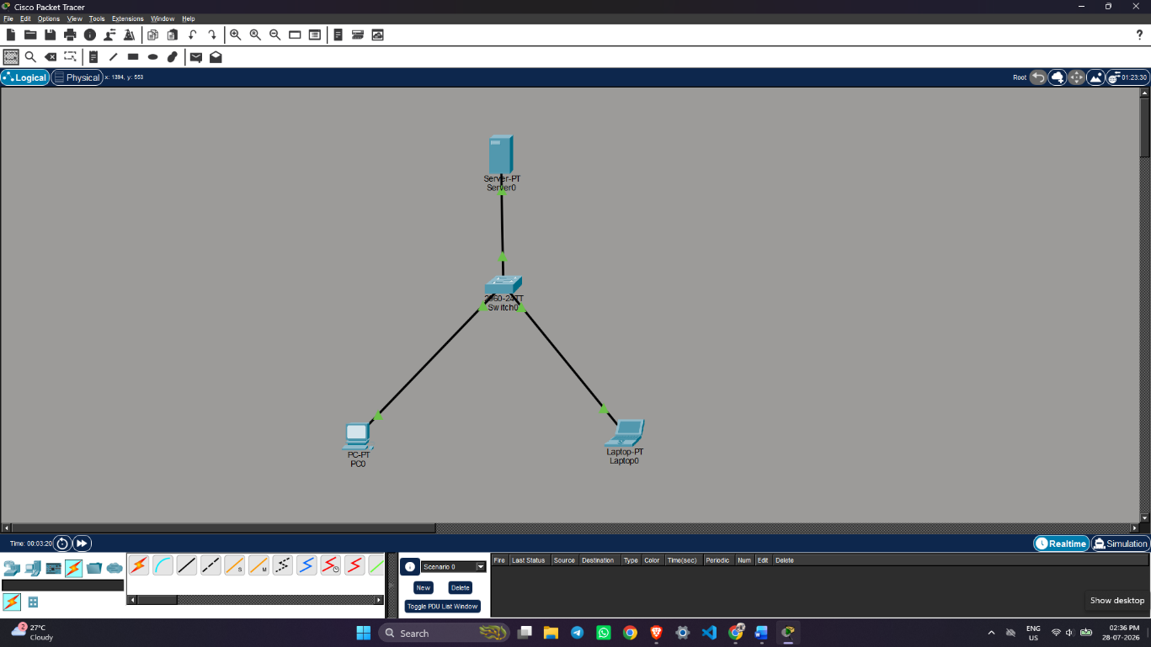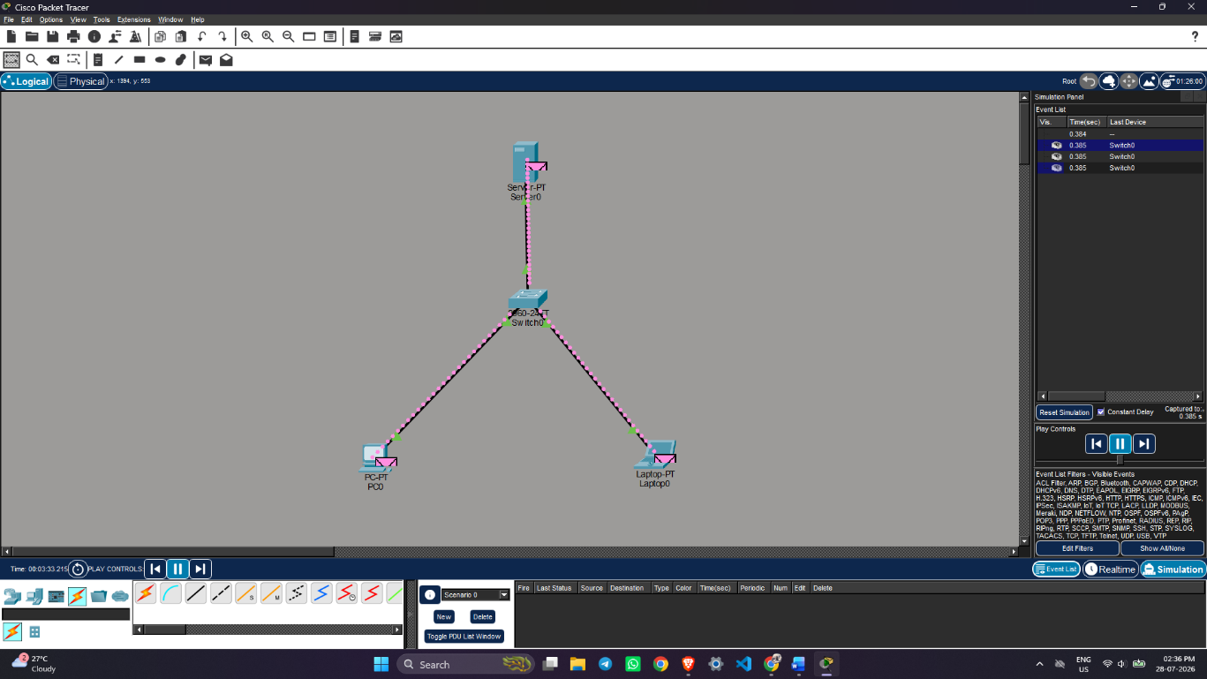
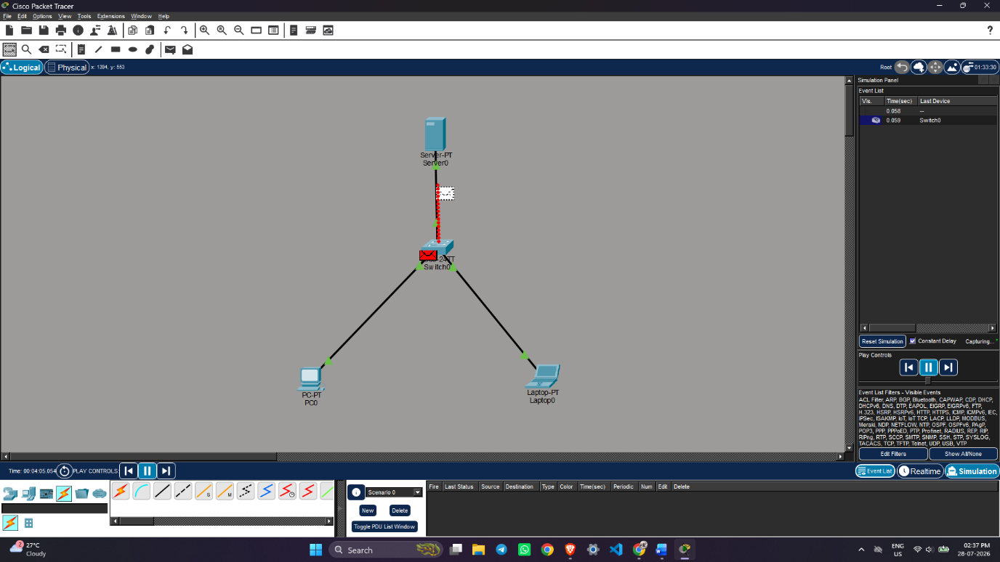
- Terminal command outputs

- color
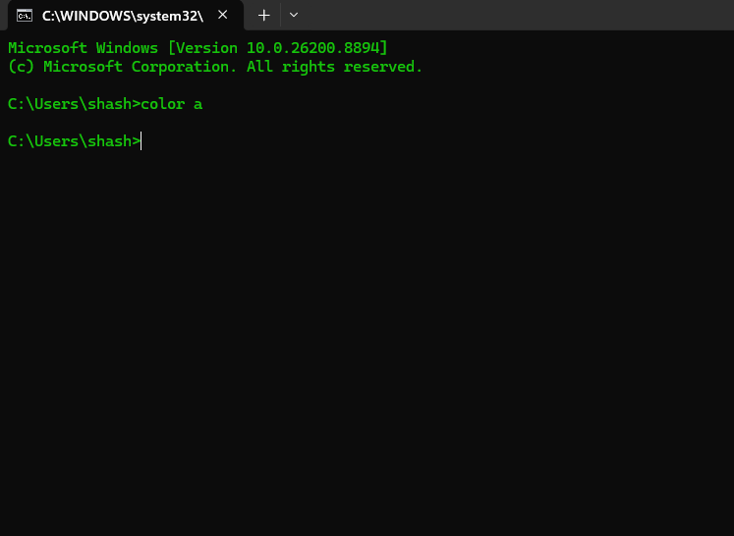
- ipconfig
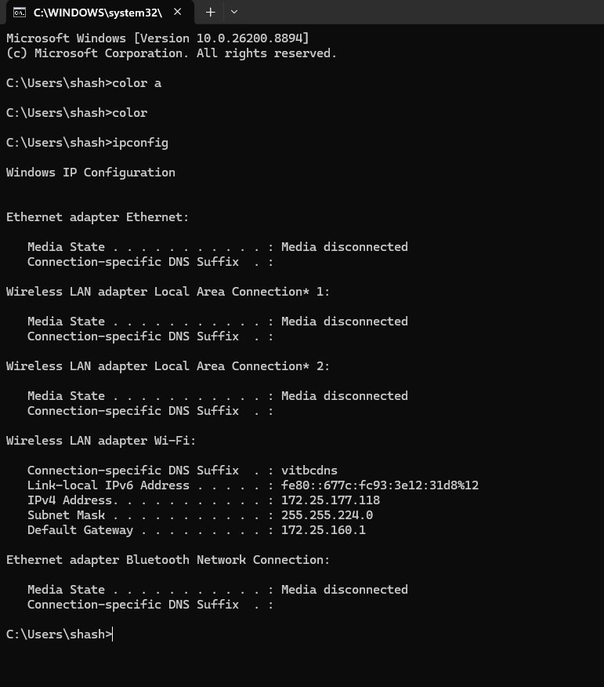

- ipconfig /all
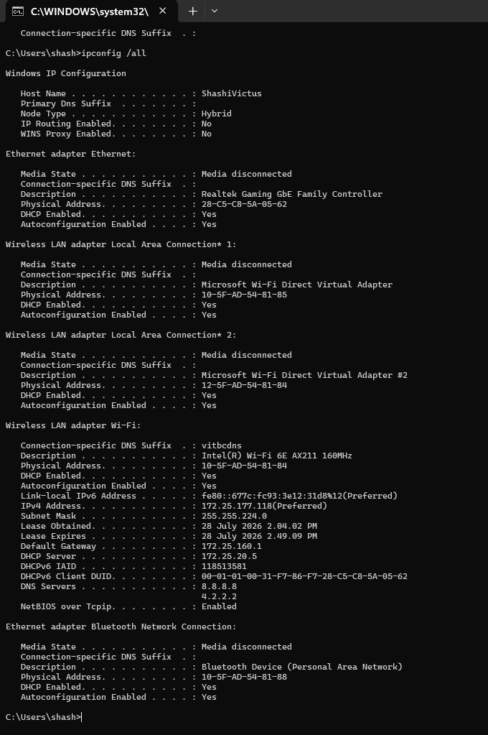
- ping google.com
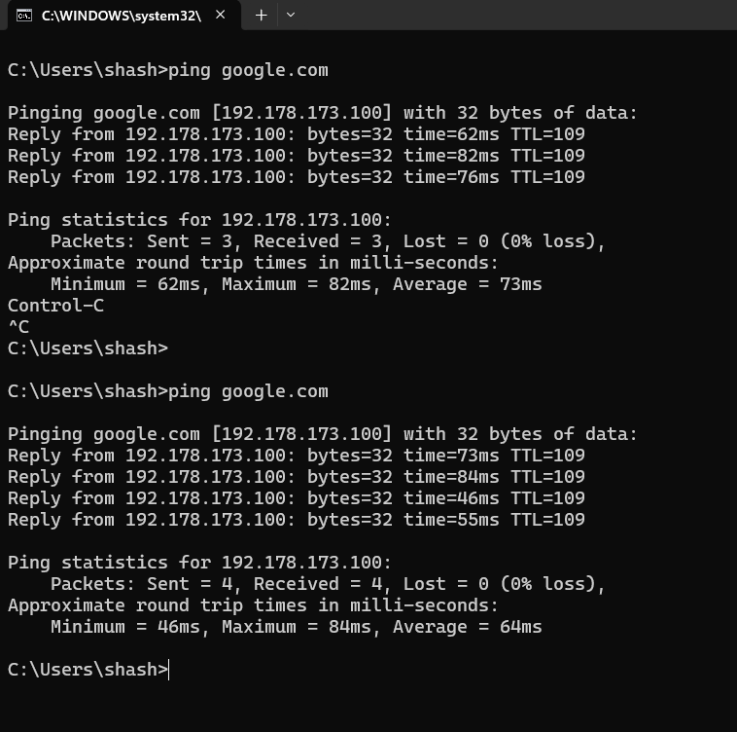

- nslookup google.com
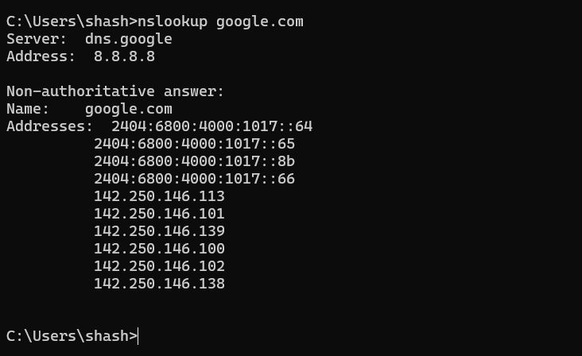

b) LAN Configuration
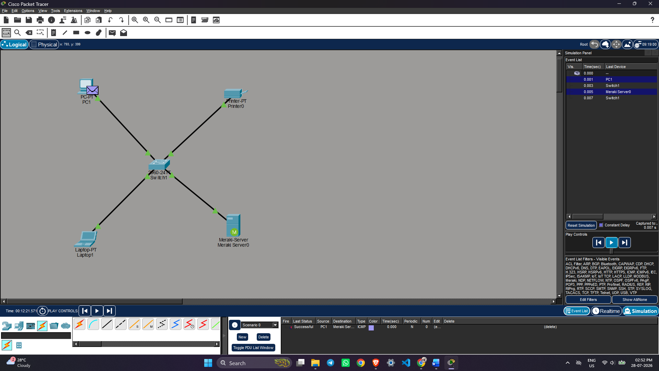
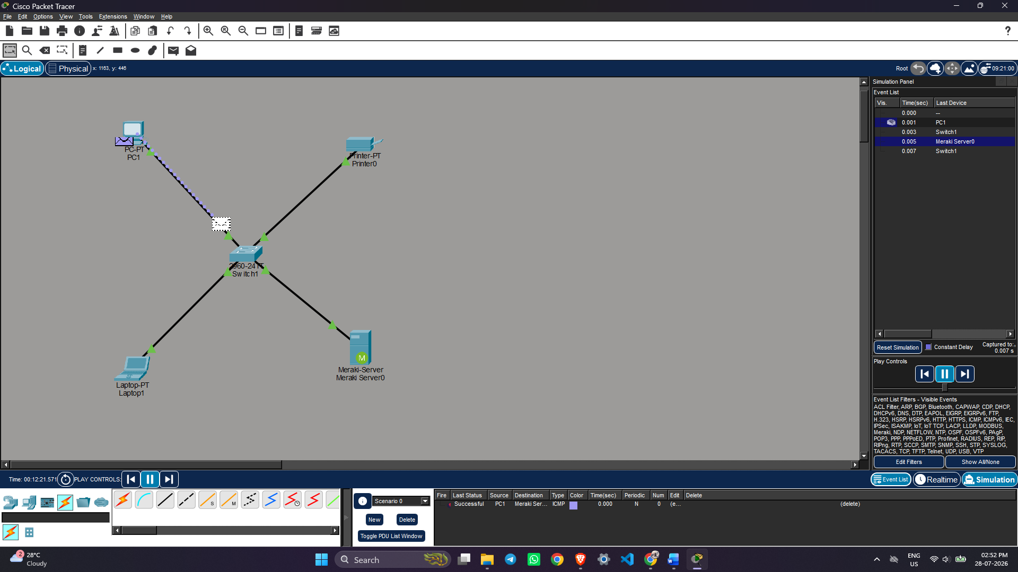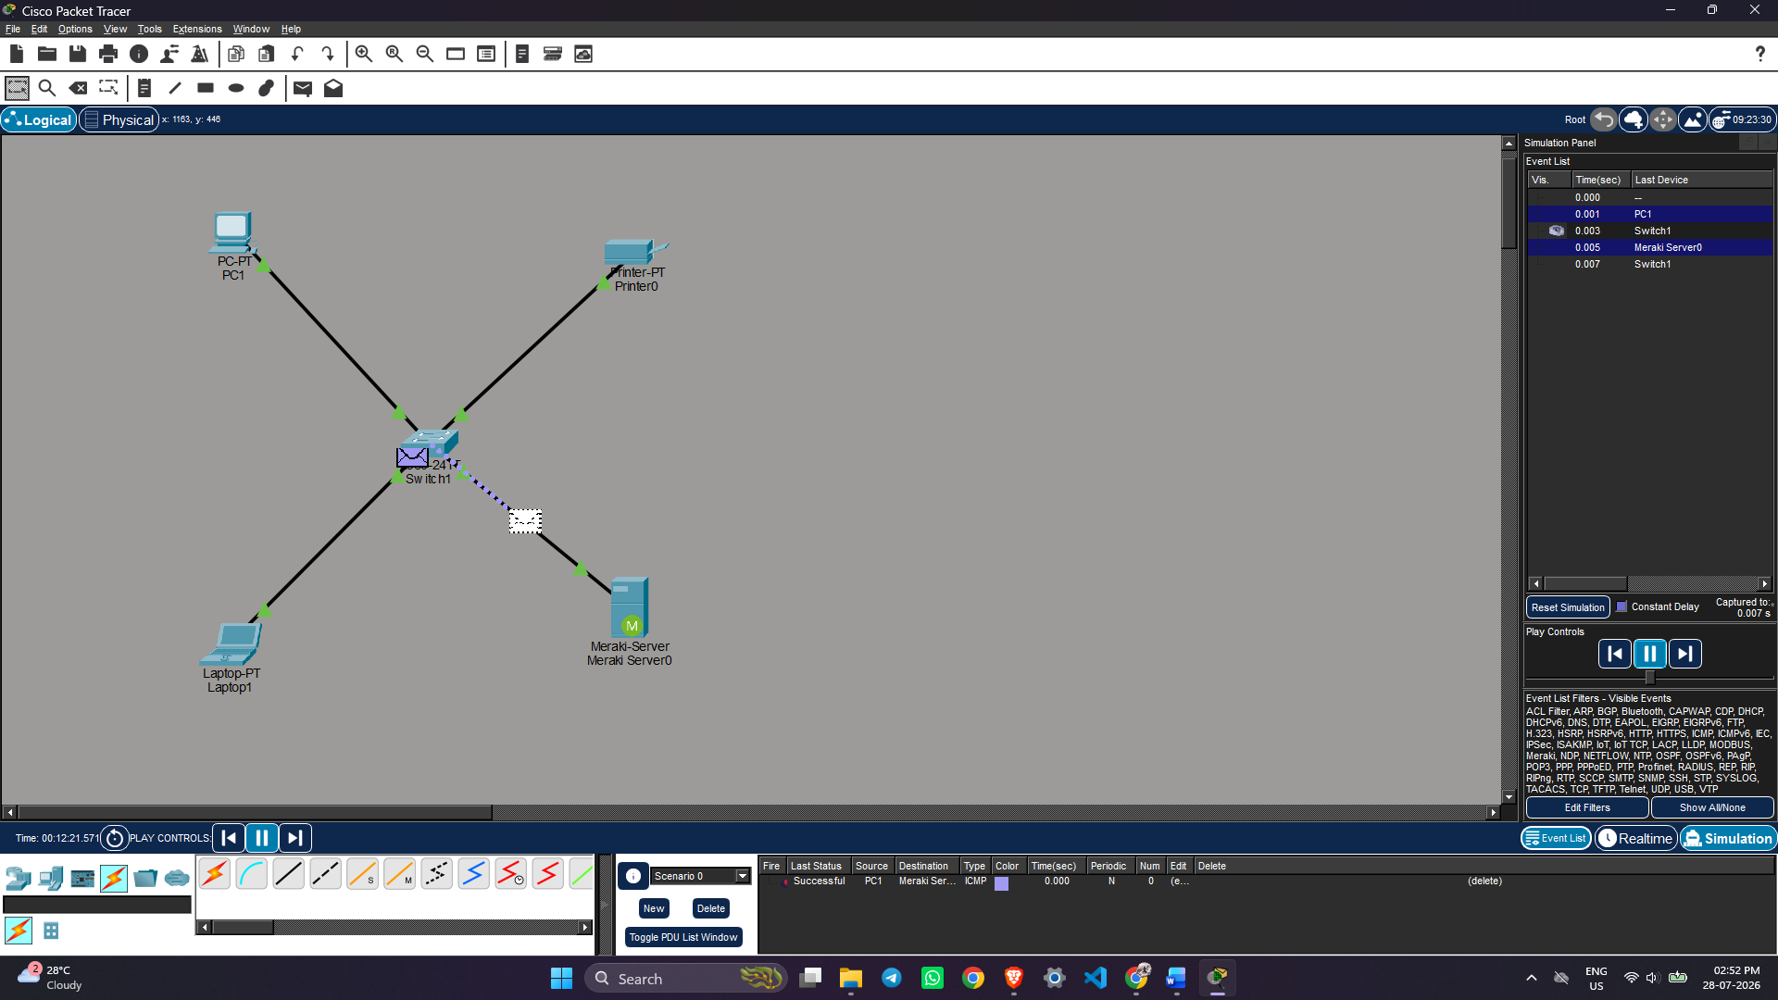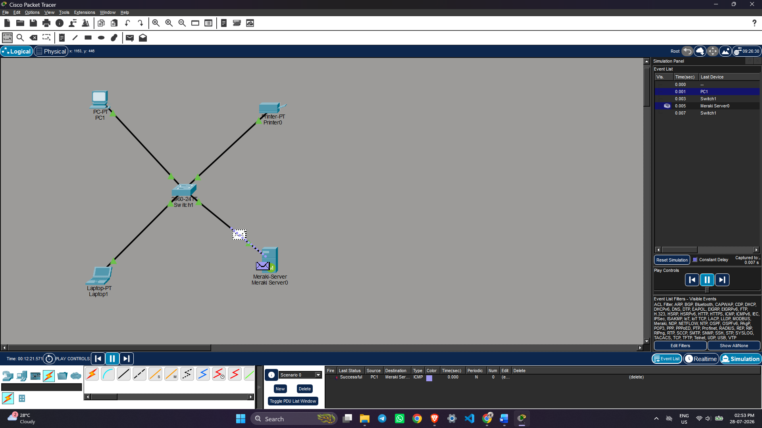

Result:
- The function of various commands (some network-related, some general purpose) in the Command Prompt is executed and learnt about Cisco Packet Tracer, and how to simulate basic networks.
- A simple LAN network using a switch and Hub is created and executed in cisco packet tracer.
References:
1. https://www.netacad.com/courses/packet-tracer
2. https://skillsforall.com/course/getting-started-cisco-packet-tracer
3. https://www.cloudflare.com/learning/network-layer/what-is-a-lan/
4. https://www.tutorialspoint.com/what-are-switches-in-computer-network

Exp No: 2 | Configure Mesh, Ring, Bus, Star and Hybrid Topologies using Cisco Packet Tracer
1.08.2026

Aim:
To configure and simulate Mesh, Ring, Bus, Star, and Hybrid network topologies using Cisco Packet Tracer and analyze their communication characteristics.
Objectives:
- To create different network topologies in Cisco Packet Tracer.
- To configure IP addresses for all network devices.
- To simulate data transmission in each topology.
- To compare the behavior and communication of different network topologies.
Simulation Tool:
Cisco Packet Tracer
Theory:
A network topology defines the physical or logical arrangement of devices in a network. Different topologies are used depending on network size, cost, reliability, and performance requirements.
- Bus Topology: All devices are connected to a single communication cable called the bus. Data travels along the cable, making it simple and inexpensive, but failure of the main cable can disrupt the entire network.
- Star Topology: Every device is connected to a central hub or switch. It is easy to install, manage, and troubleshoot. Failure of one cable affects only one device, but failure of the central device affects the entire network.
- Ring Topology: Devices are connected in a circular path where data travels around the ring. It provides orderly communication but can be affected if one connection fails.
- Mesh Topology: Every device is connected directly to every other device. It offers high reliability and fault tolerance but requires more cables and higher installation cost.
- Hybrid Topology: A combination of two or more network topologies. It provides flexibility, scalability, and improved performance by combining the advantages of different topologies.
Each topology has its own advantages and limitations regarding scalability, fault tolerance, maintenance, and cost. The choice depends on the requirements of the network.

Output: (Simulation Screen Shots)
- STAR Topology:
Basic structure:
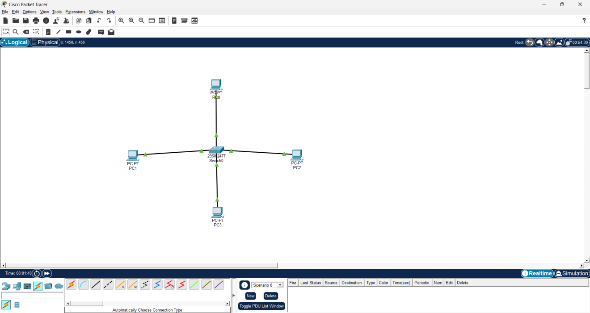

IP Congifuration:
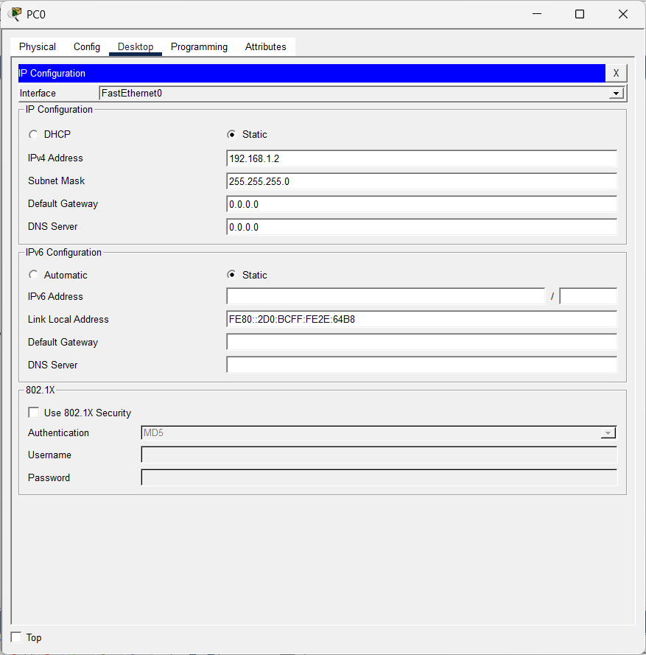

PING Status:
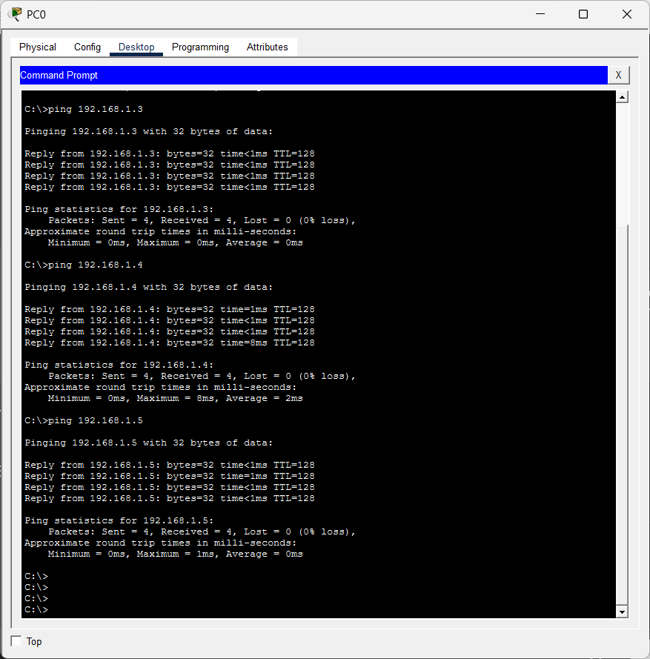
Simulation:
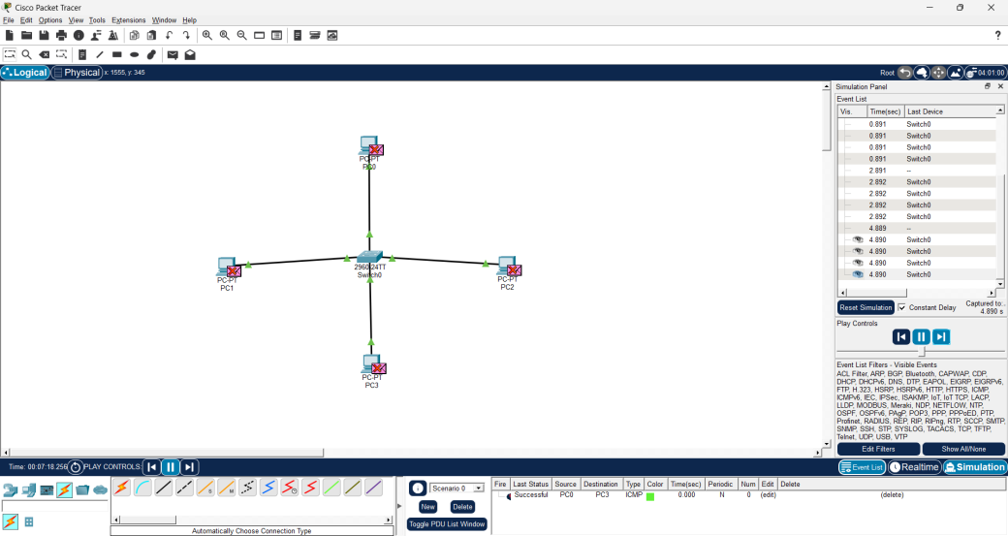

- BUS Topology:
Basic Structure:
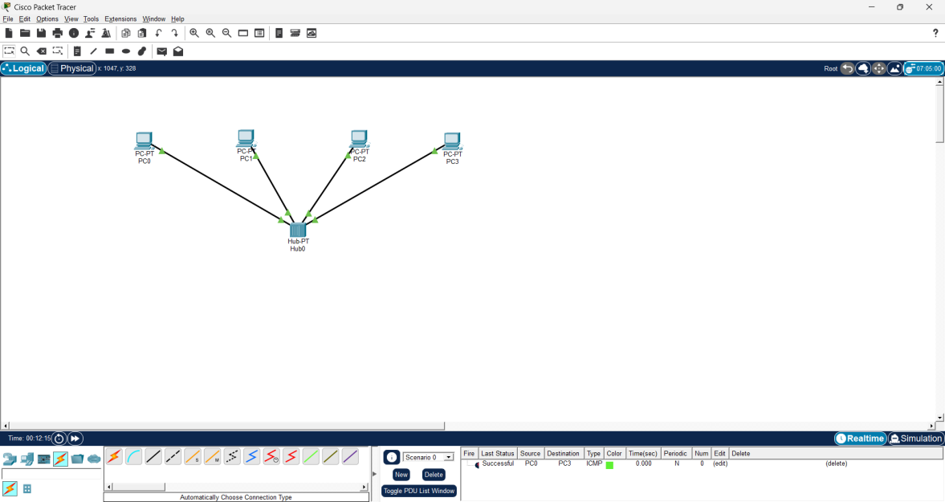
IP Configuration:
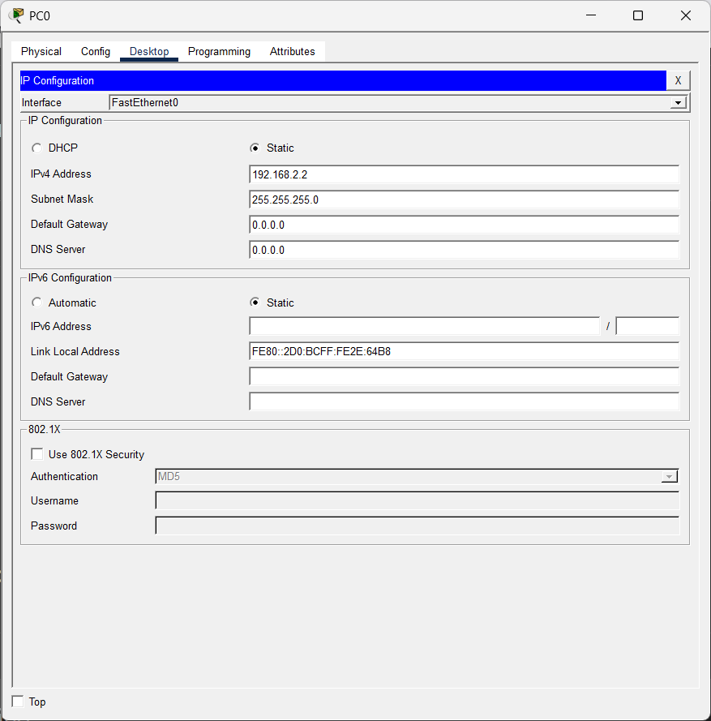

Ping Status:
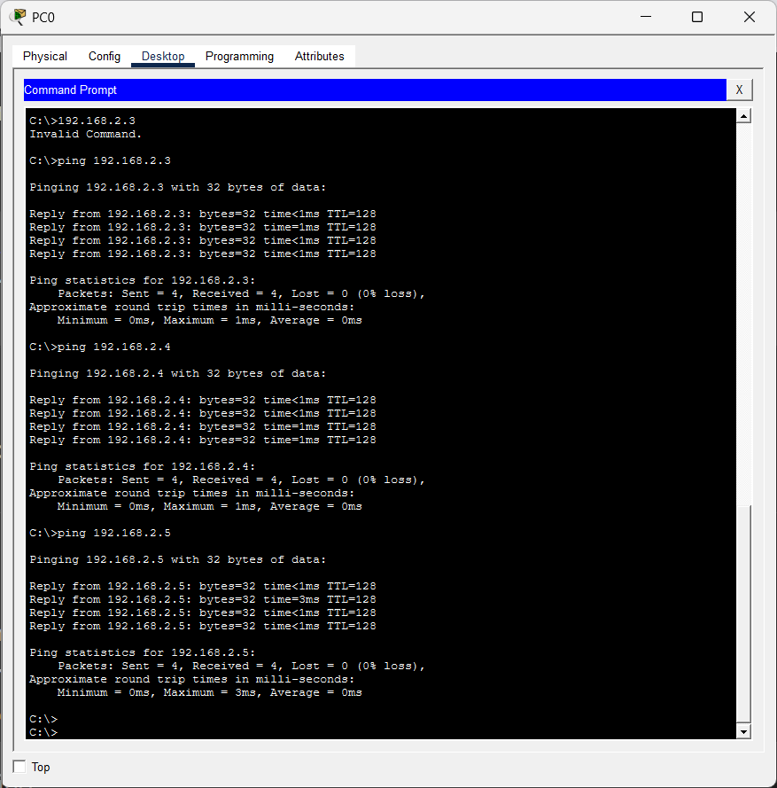
Simulation:
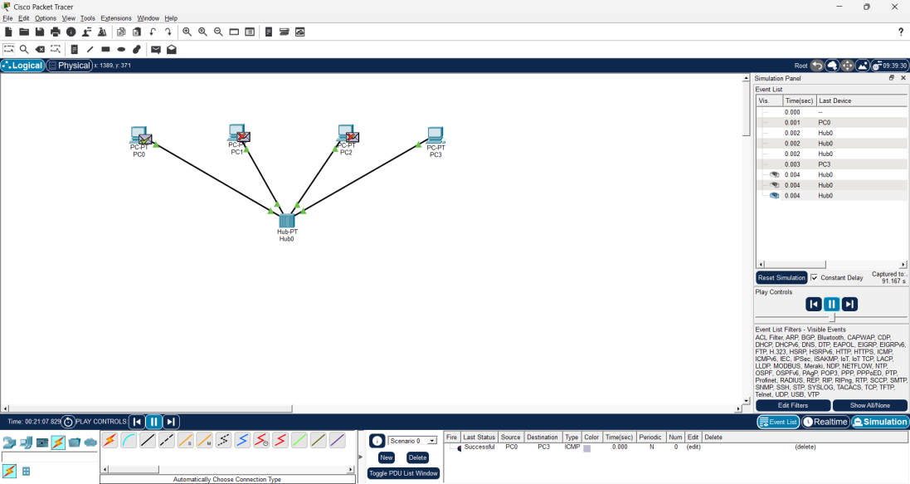

Ring Topology:
Basic structure:
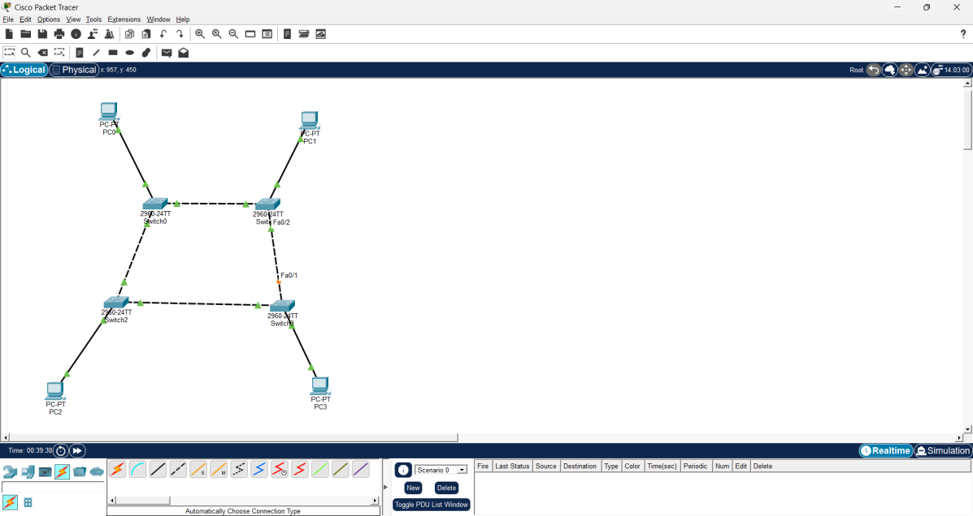
IP Configuration:
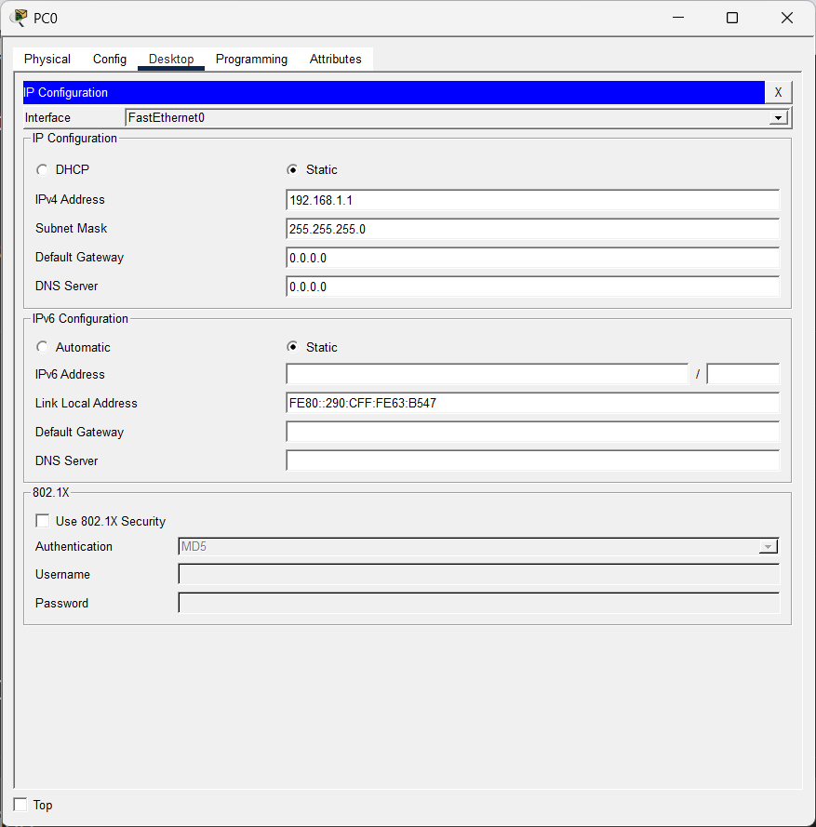
Ping Status:
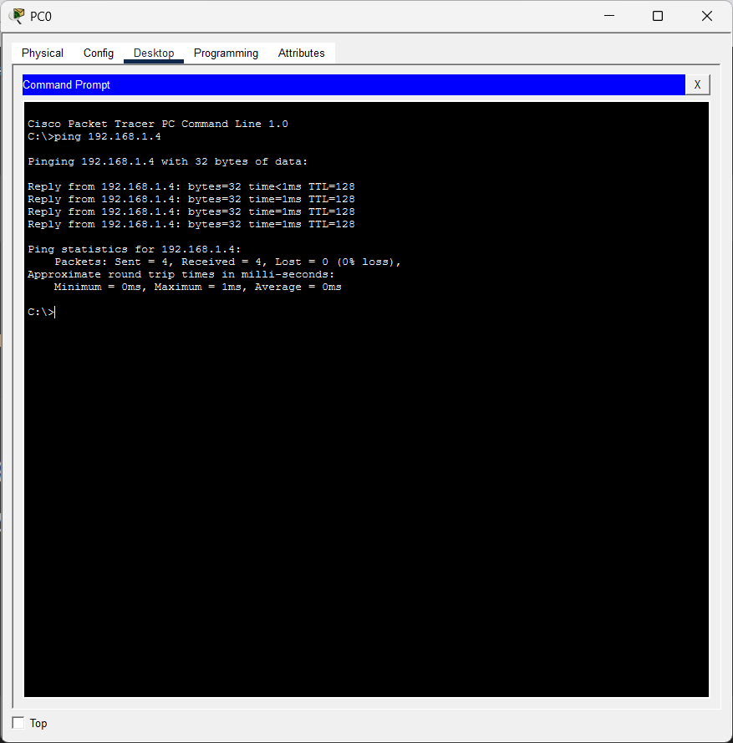
Simulation:
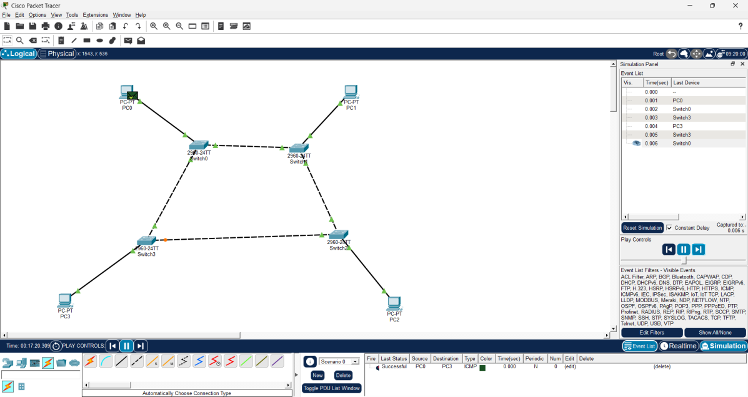

Mesh Topology:
Basic structure:
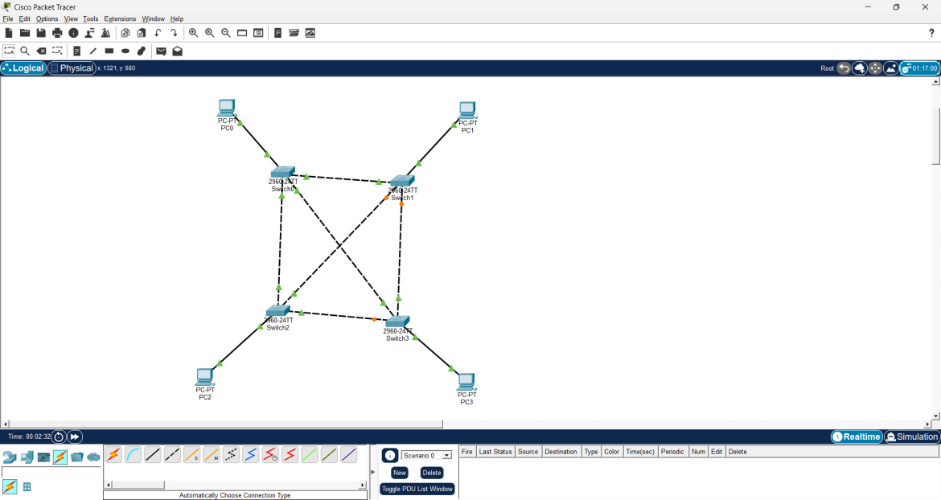

IP Configuration:
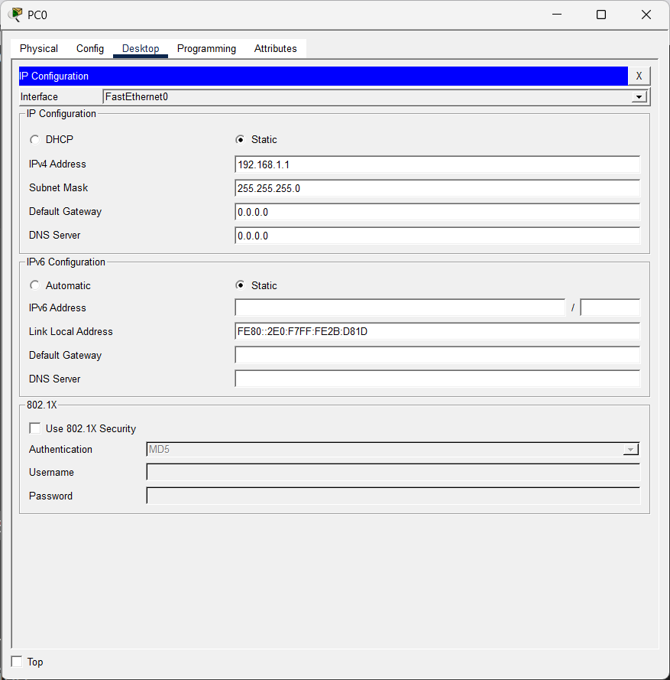
Simulation:
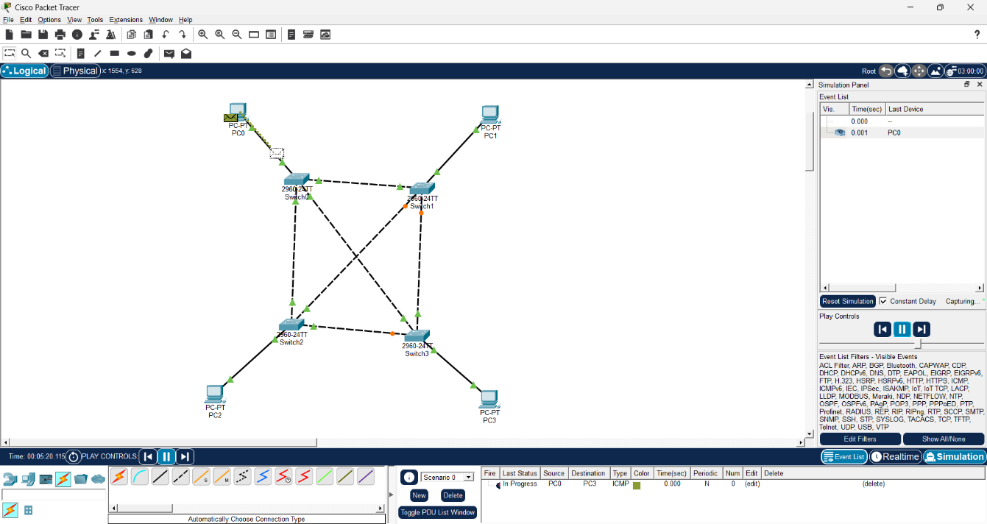
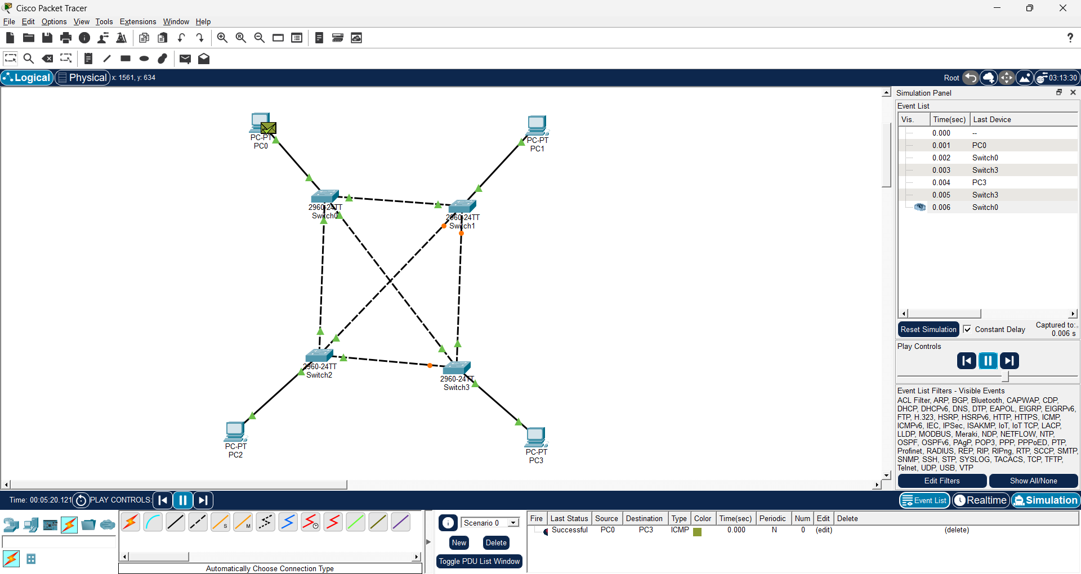

Hybrid Topology:
Basic Structure:
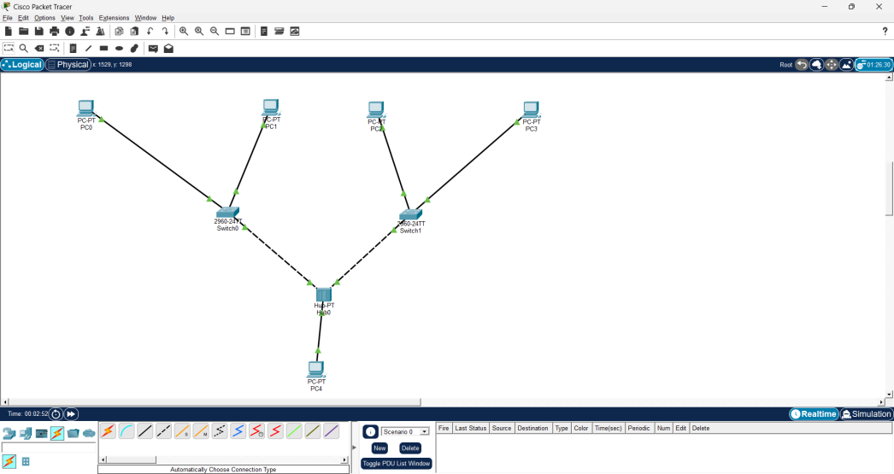
IP configuration:
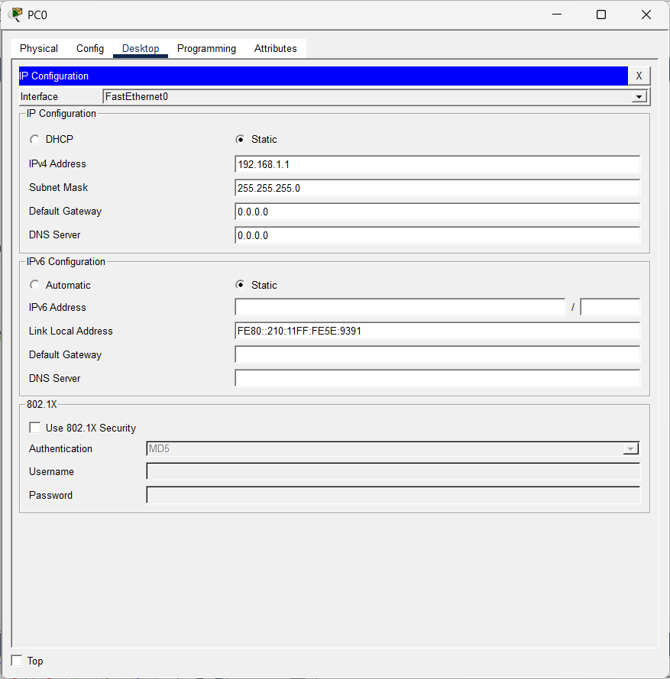

Ping Status:
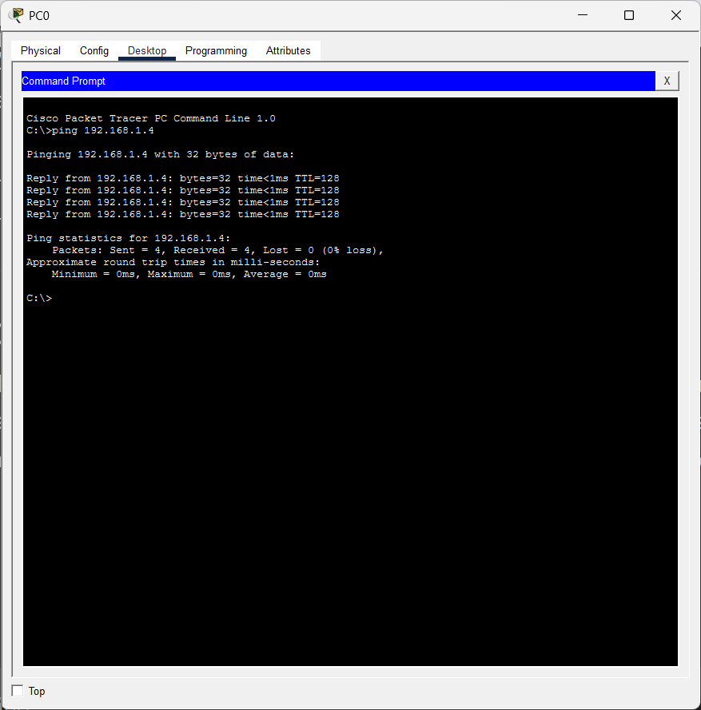
Simulation:
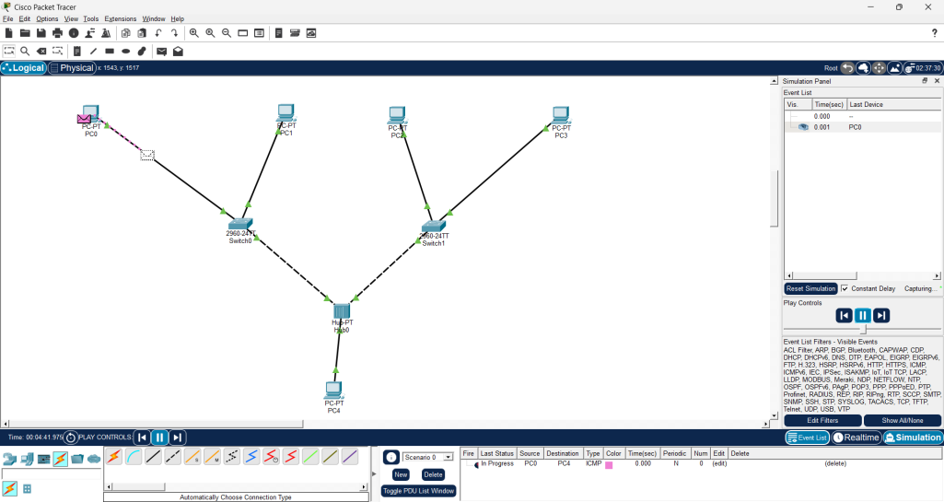

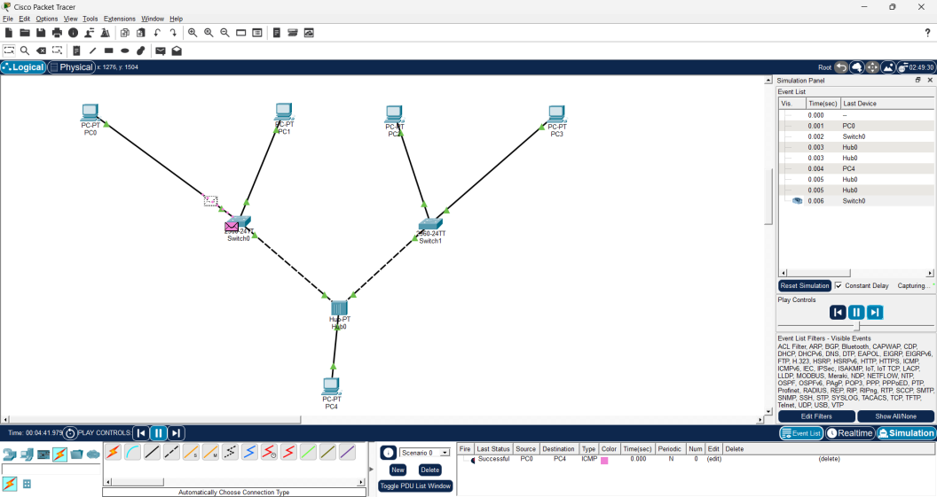
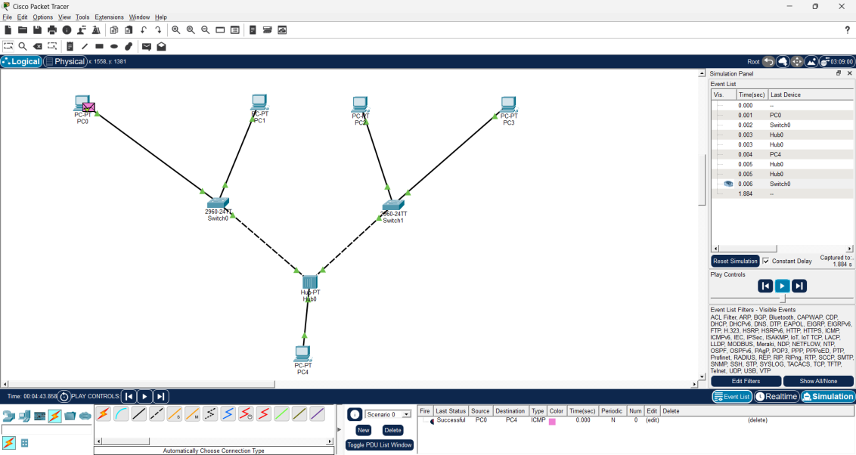

Result
Successfully configured inter-LAN communication using a router and verified communication between different LANs. The working of repeaters and bridges was also demonstrated successfully using Cisco Packet Tracer, confirming proper signal transmission and network segmentation.
References:
  - https://www.netacad.com/courses/packet-tracer
  - https://skillsforall.com/course/getting-started-cisco-packet-tracer
  - https://www.cloudflare.com/learning/network-layer/what-is-a-lan/

Exp No: 3 | Inter-LAN Communication using Router Configuration and Working of Repeaters and Bridges
8.08.2026

Aim:
- To connect two Local Area Networks (LANs) and enable communication between them using a router.
- To demonstrate the working of repeaters and bridges using Cisco Packet Tracer.
Objectives
- To configure a router for communication between two different LANs.
- To assign IP addresses and default gateways to all network devices.
- To understand the routing process between different networks.
- To study the working principle and applications of repeaters and bridges.
- To verify successful communication using simulation in Cisco Packet Tracer.
Simulation Tool:
- Cisco Packet Tracer
Theory:
A router is a Layer-3 networking device that connects two or more different networks and forwards data packets between them based on IP addresses. It examines the destination IP address of each packet and uses its routing table to determine the best path for forwarding the packet. Routers enable communication between different LANs and WANs while efficiently managing network traffic.
A repeater is a physical layer device that regenerates and amplifies weak or degraded signals before retransmitting them. It is mainly used to extend the communication distance of a network without changing the data being transmitted.
A bridge is a data link layer (Layer-2) device that connects two or more LAN segments. It filters and forwards frames using MAC addresses, reducing unnecessary network traffic and improving network performance.
In this practical, two separate LANs are connected through a router to establish inter-LAN communication. The working of repeaters and bridges is also demonstrated to understand their role in extending network coverage and connecting network segments efficiently.

Output:
- Repeater:
Basic Structure:
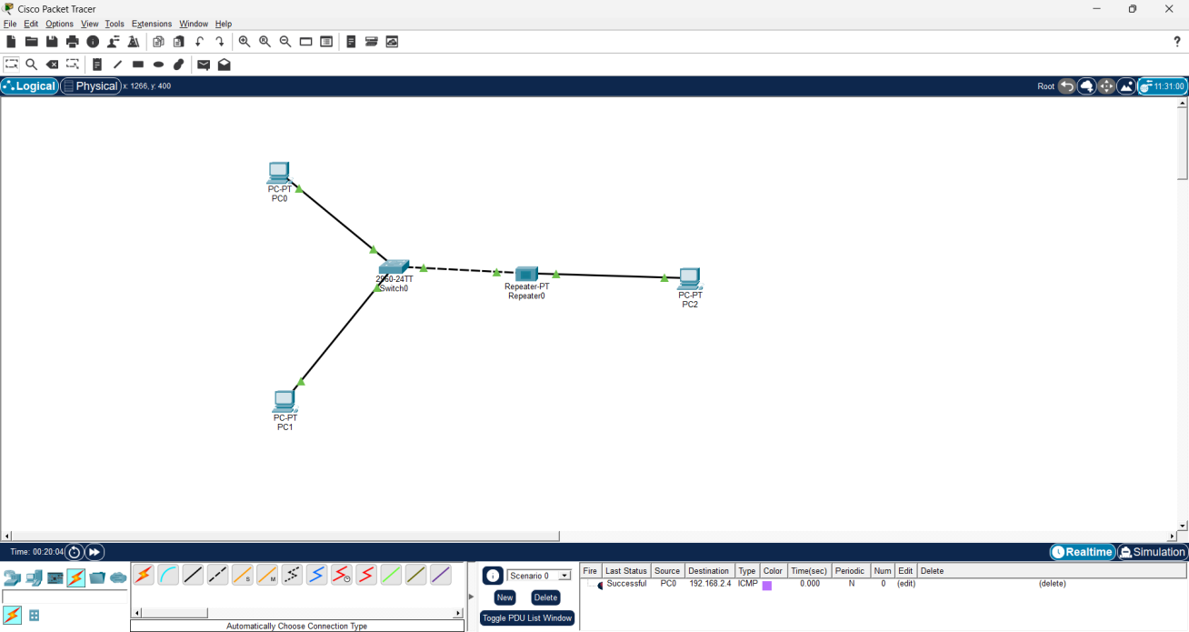

IP Configuration:
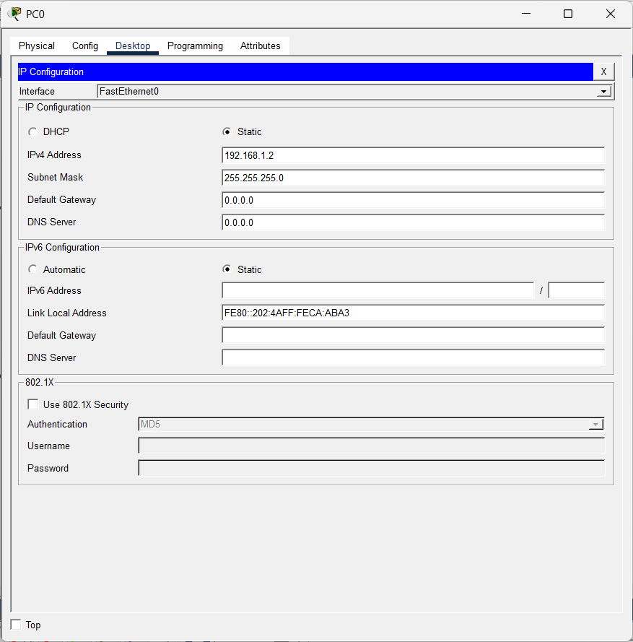

Ping Status :
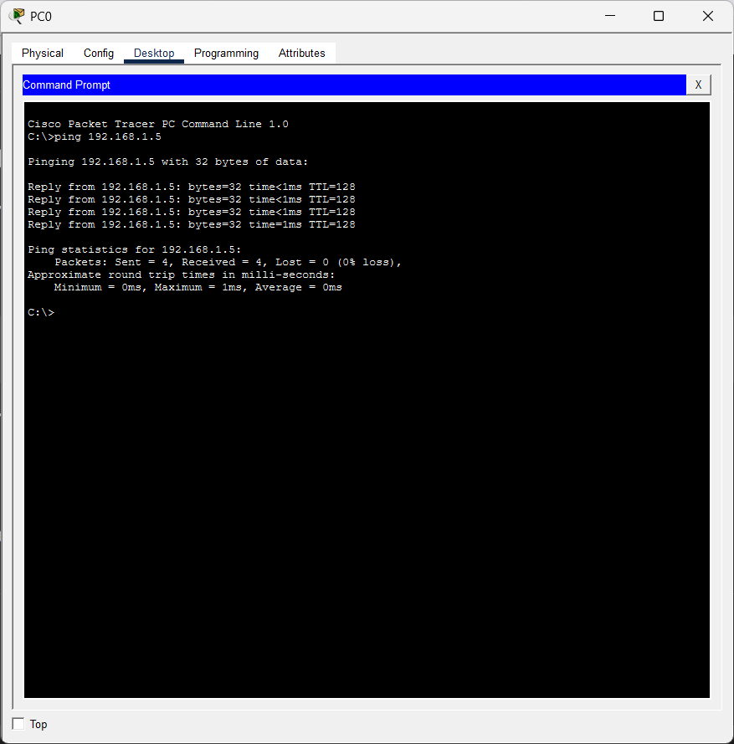
Simulation:
Initial Stage
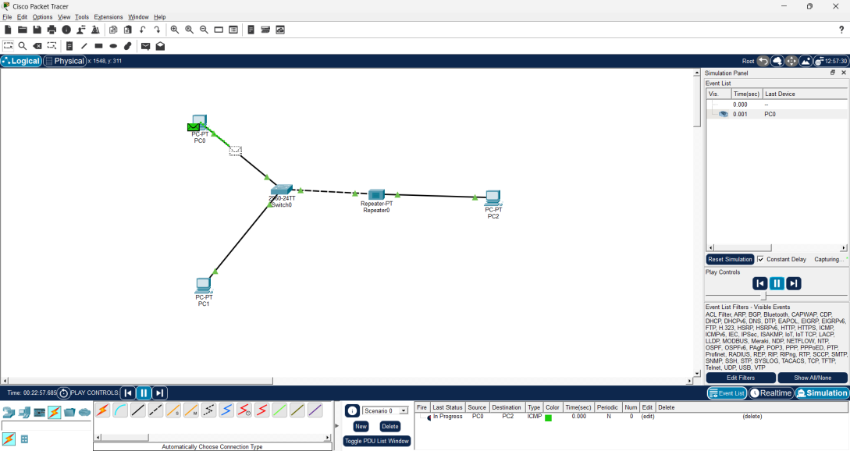
In progress
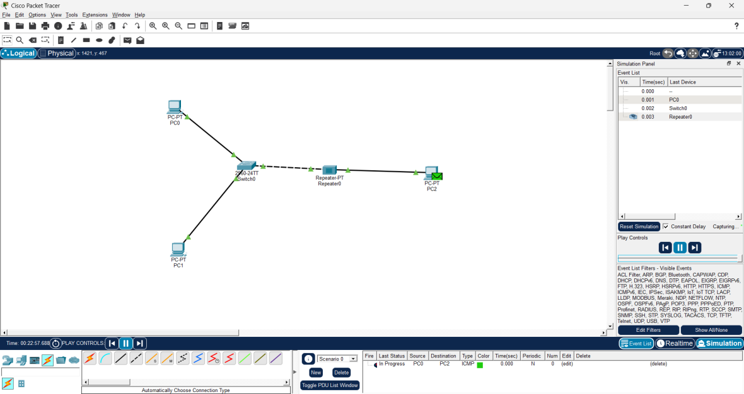
Successful
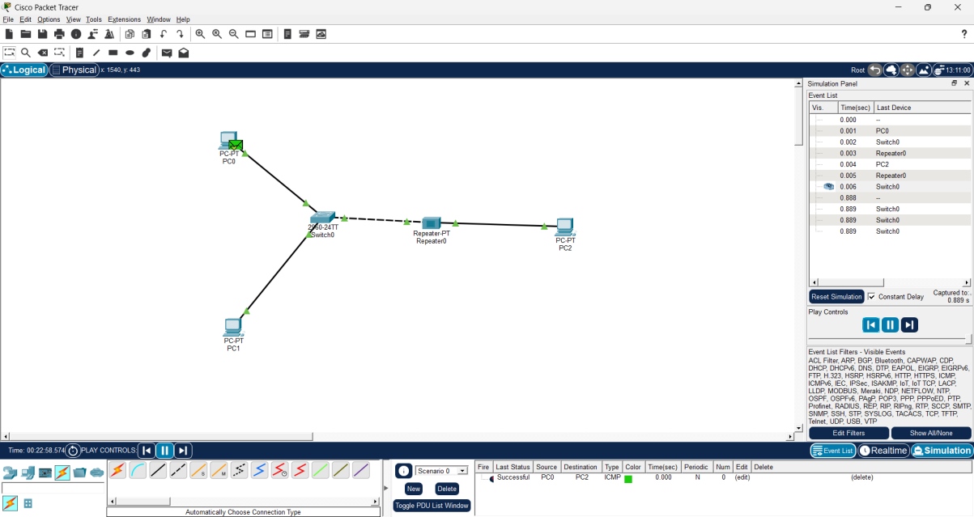

- Bridge:
Basic Structure:
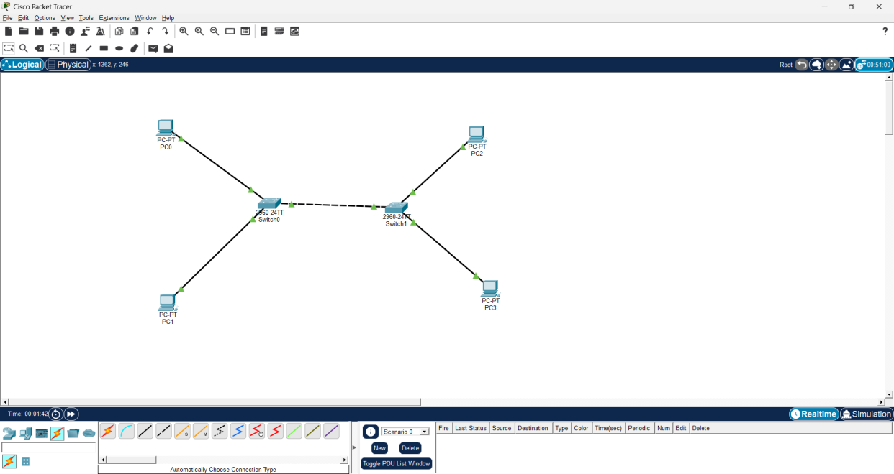
IP configuration:
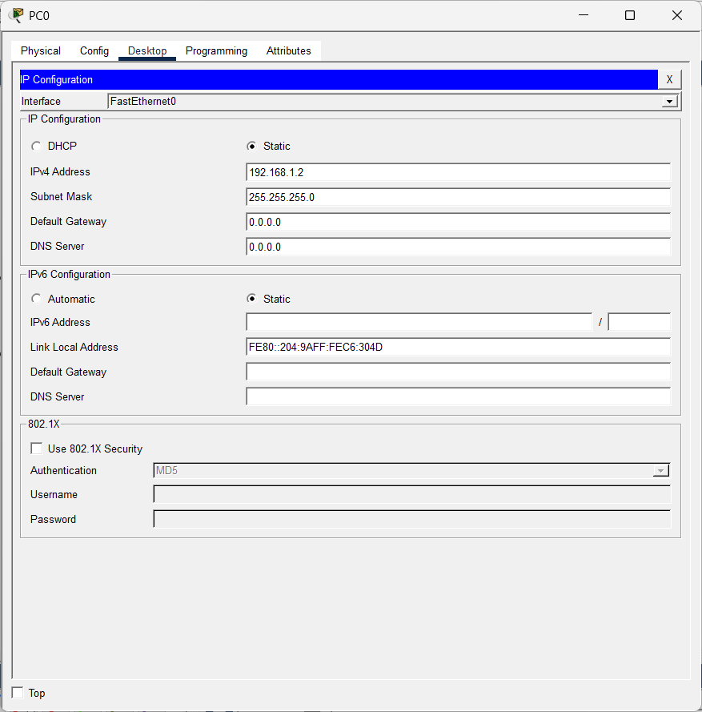

Ping Status:

Simulation:
Initial Stage:
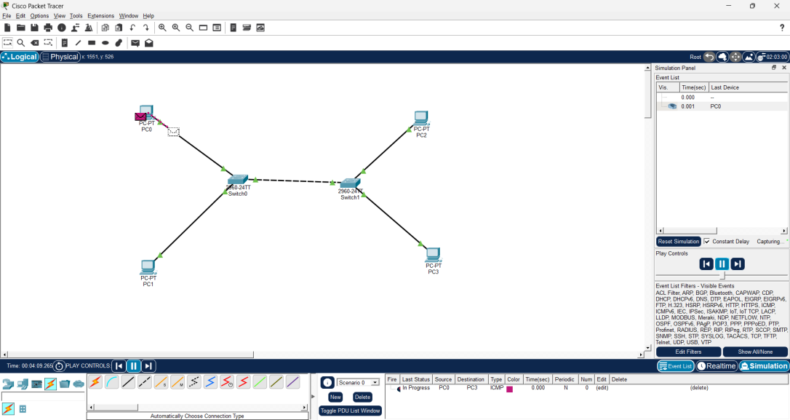
In Progress:
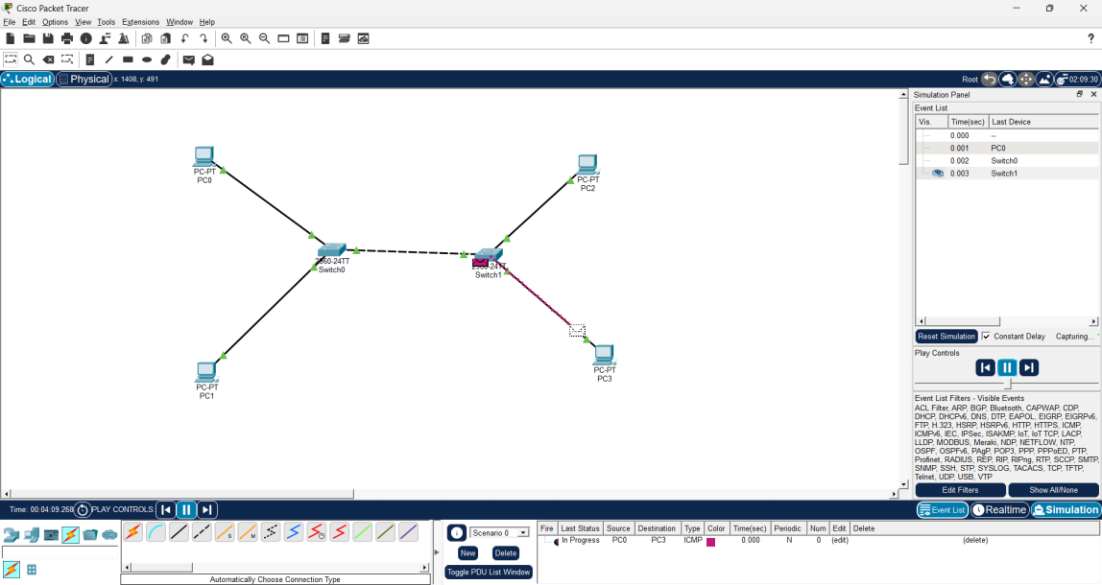

Successful:
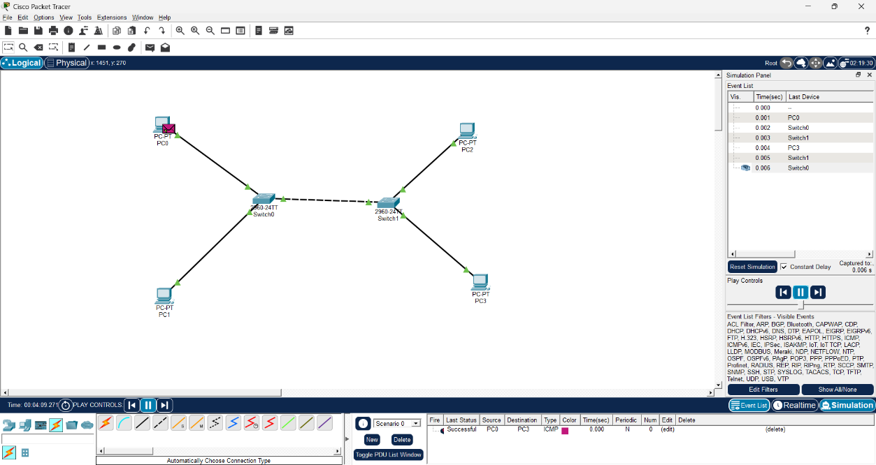

Result
Successfully configured two LANs and established communication between them using a router in Cisco Packet Tracer. The working of repeaters and bridges was also demonstrated successfully, and packet transmission was verified using Simulation Mode, confirming proper network connectivity and communication.

